To improve the card game helper, I desgined a four question survey asking the user to evaluate their experience with the app. The survey consisted of four questions, three of which asked the participant to evaluate the app using a Likert scale ranging from one to five, with one being bad and five being great. The fourth question consisted of asking the participant to respond in short answer form. The questions below are the exact layout of the survey.

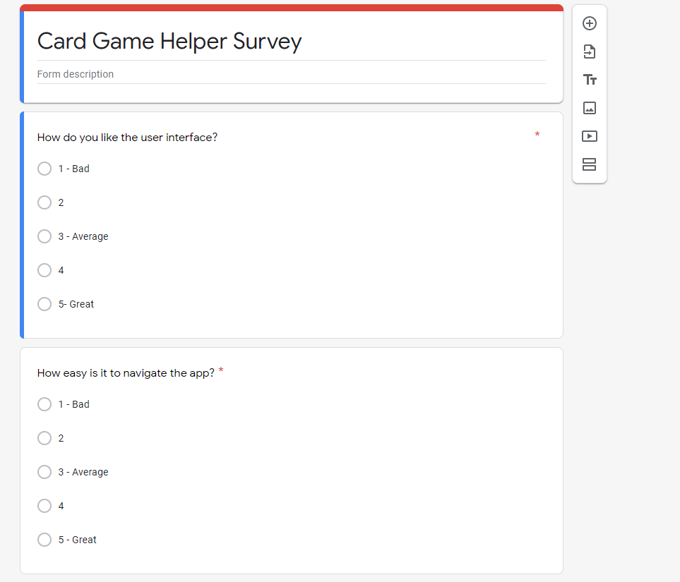

These are the first two questions on the survey.

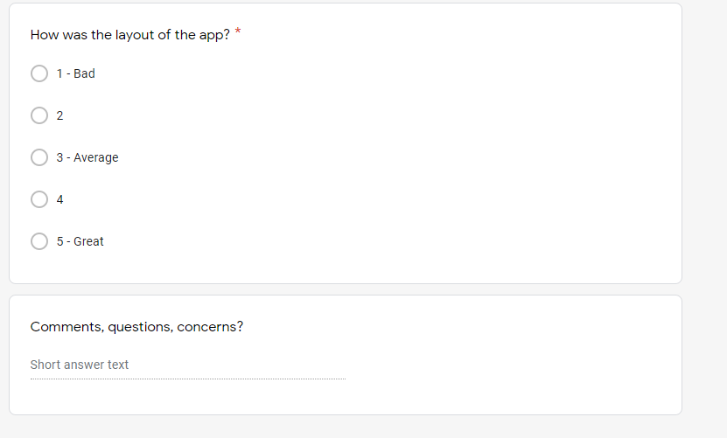

These are the third and fourth question of the survey.

The data collected combined ten responses from participants. These are the results.

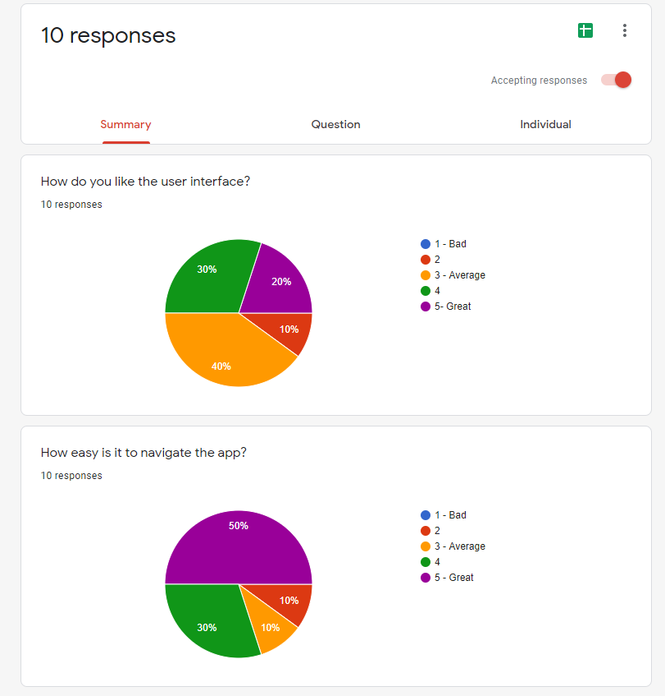

For the first question, the participants were asked to rate “how do you like the user interface?” and 40 percent responded that the user interface was average. Thirty percent responded that the user interface was above average. Twenty percent responded that the user interface was great. Ten percent responded that the user interface was below average.

For the second question, the participants were asked to rate “how easy is it to navigate the app?” and 50 percent responded that the ease of navigation was great. Thirty percent responded that the ease of navigation was above average. Ten percent responded that the ease of navigation was average. Ten percent responded that the ease of navigation was below average.

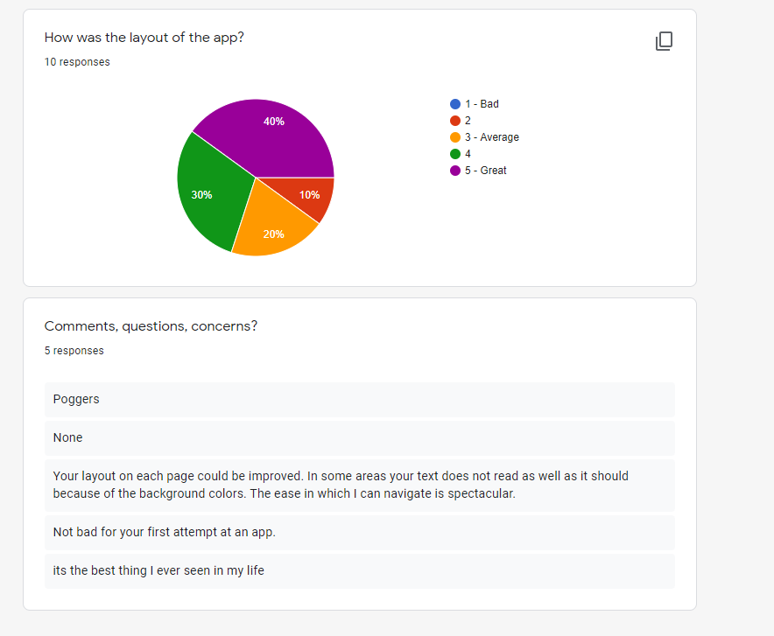

These are the third and fourth responses of the questions.

For the third question, the participants were asked to rate “how was the layout of the app?” and 40 percent responded that the layout was great. Thirty percent responded that the layout was above average. Twenty percent responded that the layout was average. Ten percent responded that the layout was below average.

For the fourth question, the participants were asked to write in short answer form any comments, questions, or concerns. One participant responded, “not bad for your first attempt at an app”. Another comment responded, “Your layout on each page could be improved. In some areas your text does not read as well as it should because of the background colors. The ease in which I can navigate is spectacular.”

In summary, I had the participants run through the app at their own pace and let them choose the paths so it would not be super complicated to them. I ask them how they liked the user interface, how easy it was to navigate the app, and how the layout of the app was. Only one or two of the participants have seen the app before, so to many the app was fresh to them. My first impression of the data is that the users did not fall in favor of the user interface because 70% of the users that the interface was average or below. When looking at the next question 80% of the users thought that the app was easy to navigate. On the final question the 70% users thought that the app was in a good layout.